# Lab 8

# Experiment 1 :

# 

package question1;

import java.util.*;

class Student{

String name;

int RollNo;

Student(){

System.*out*.println("Default constructor");

}

Student(String name,int rollNo){

this.name = name;

this.RollNo = rollNo;

}

}

public class StudentException {

public static void main(String[] args) {

Scanner in = new Scanner(System.*in*);

try{

Student[] studentArray = new Student[10];

String s = "a";

int rollno = 1;

for(int i=0;i<11;i++){

studentArray[i] = new Student(s,rollno);

s = s + 'a';

rollno += 1;

}

for(Student x : studentArray)

System.*out*.println(x.name +" " + x.RollNo);

}catch(ArrayIndexOutOfBoundsException a){

System.*out*.println("Exception Caught successfully\n" + a);

}

}

}

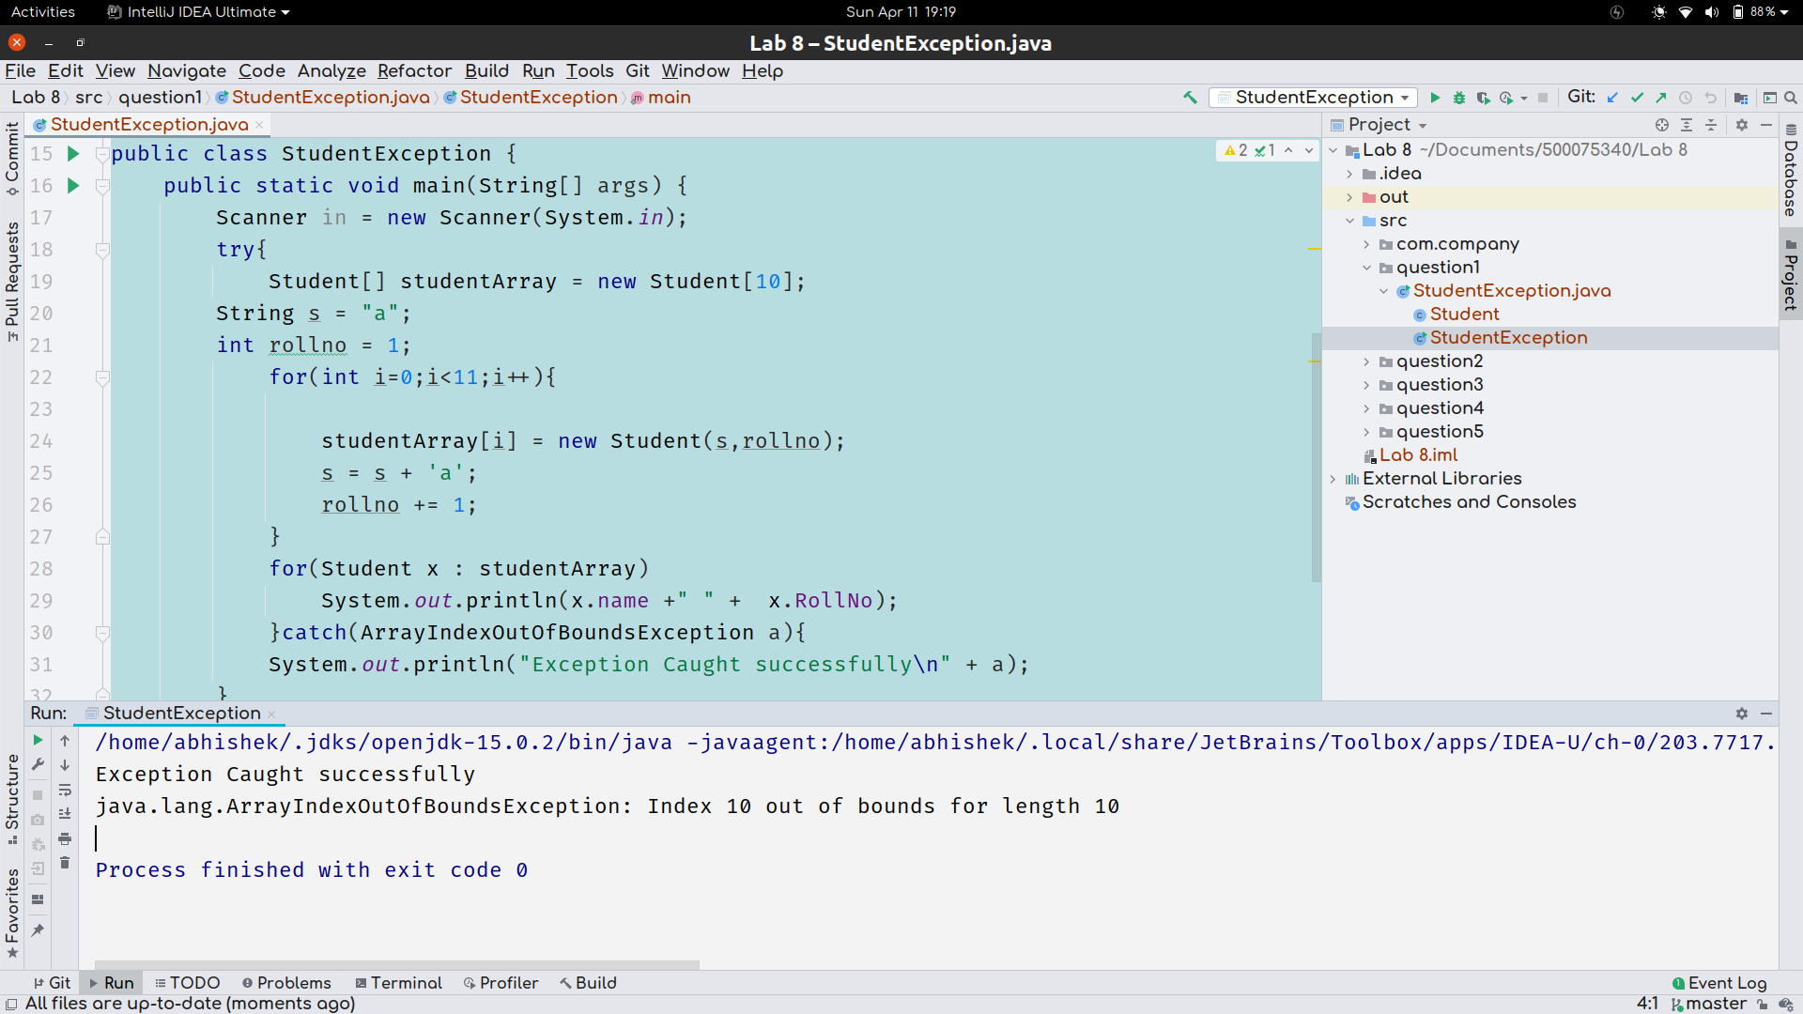

Question 2 :

package question2;

public class DivideByZero {

public static void main(String[] args) {

try{

int a= 10;

int b = 0;

System.*out*.println(a/b);

}catch(ArithmeticException a){

System.*out*.println(a + " successfully handled");

}

}

}

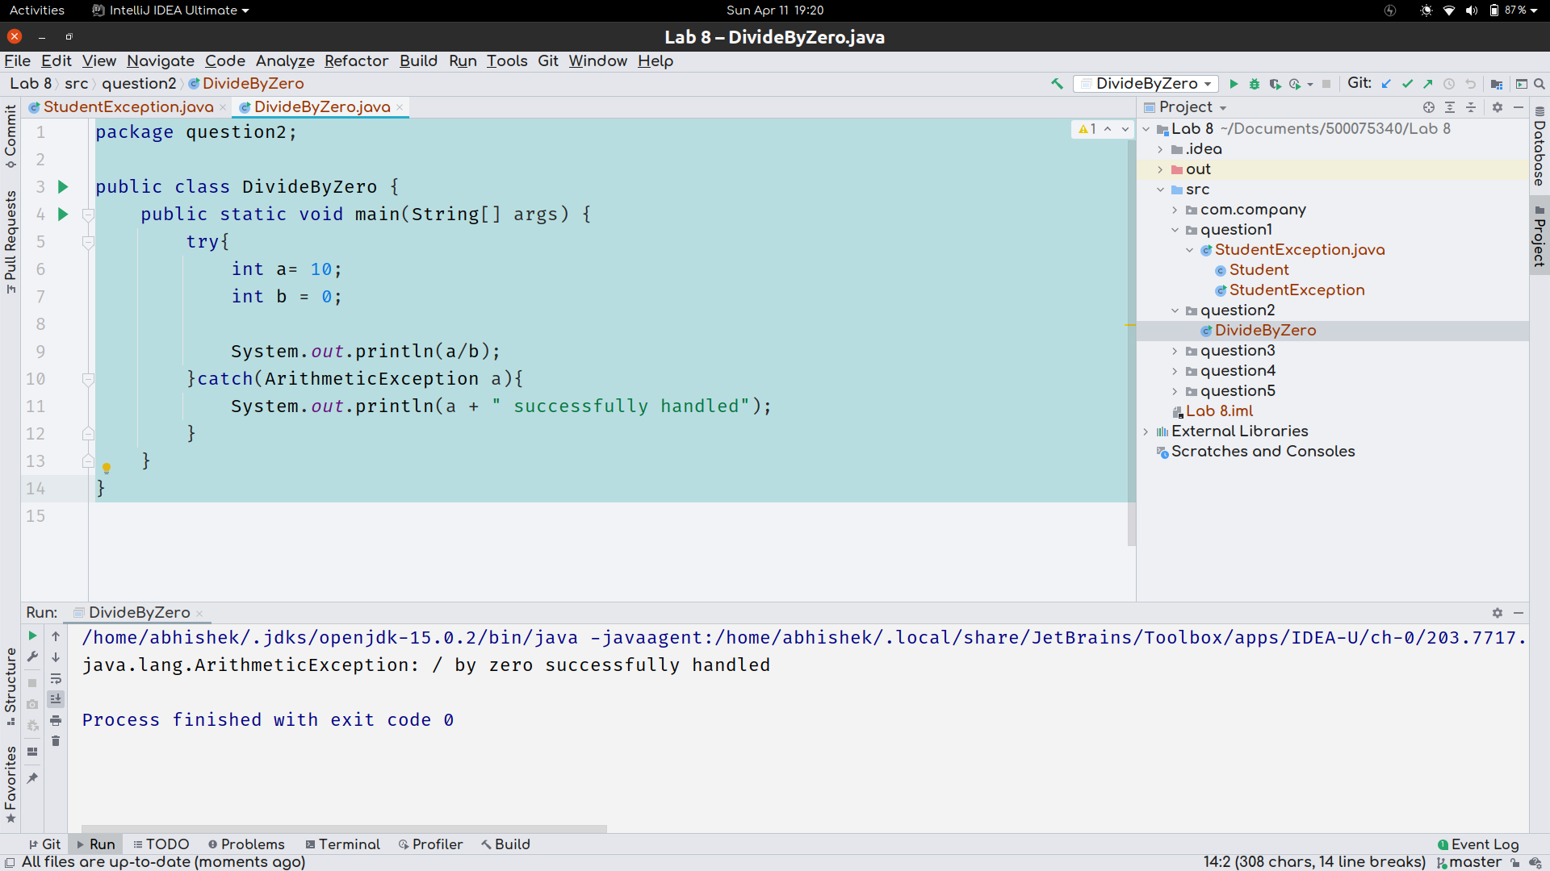

Question 3 :

package question3;

class NotNumber extends Exception{

NotNumber(){

super("This is not integer value exception");

}

}

public class ExceptionClass extends Exception {

public static void main(String[] s) {

int a,b;

try{

a = Integer.parseInt(s[0]);

b = Integer.parseInt(s[1]);

int c = a %b;

System.*out*.println(c);

throw new NotNumber();

}

catch(NumberFormatException N){

System.*out*.println(N);

}

catch(NotNumber n){

System.*out*.println(n);

}

catch(Exception e)

{

System.*out*.println(e + "find");

}

}

}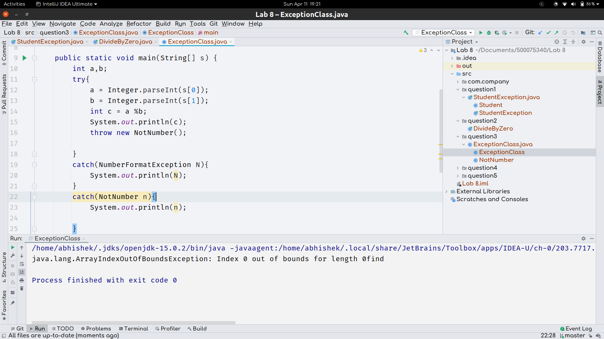

Question 4 :

package question4;

import question3.ExceptionClass;

class CollisionException extends Exception{

public CollisionException(String s){

super(s);

}

}

class Car{

// this distance is from origin

int dist;

Car(int dist){

this.dist = dist;

}

}

public class CollisionDetection {

static void detectCollision(Car A, Car B) throws CollisionException{

int a= A.dist;

int b = B.dist;

while(a<b){

a +=1 ;

b -= 1;

if(a>=b){

throw new CollisionException("Collision Avoided Successfully");

}

}

}

public static void main(String[] args) {

// let say we are going to take one car distance in positive

// other one car distance from origin in negative

Car A = new Car(40);

Car B = new Car(140);

try {

CollisionDetection.detectCollision(A,B);

}

catch(CollisionException E)

{

System.*out*.println(E.getMessage());

System.*out*.println(E);

}

}

}

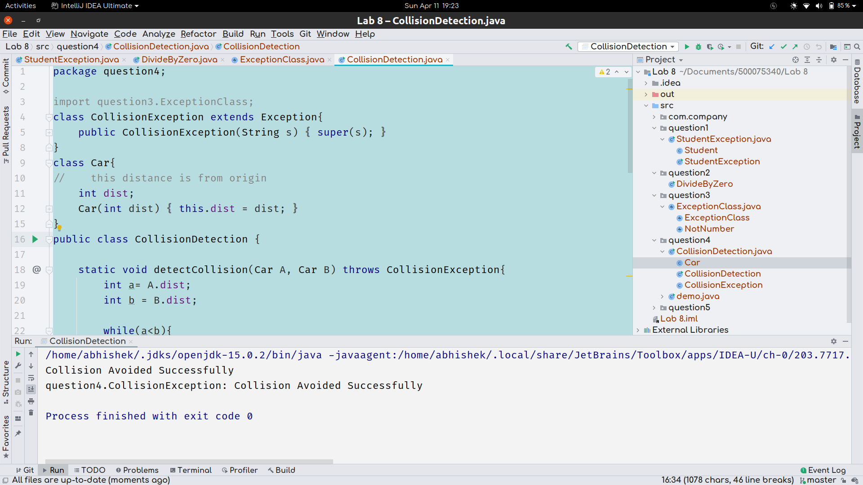

# 

# Question 5 :

package question5;

import java.util.*;

import java.io.*;

public class Employee {

public static void main(String args[])

{

String name;

int age;

Scanner in=new Scanner(System.*in*);

try

{

if(!(in.nextLine().matches("[a-zA-Z]+")))

{throw new IOException();}

age=in.nextInt();

if(age>50)

{

System.*out*.println("Age greater than 50 Exception");

throw new Exception();

}

Employee e = new Employee();

}

catch(Exception e)

{

System.*out*.println("Exception");

}

}

}

